|  |  |
| --- | --- |
| **Team ID** | PNT2022TMID50137 |
| **Project Name** | Smart Fashion Recommender Application |

DOCKER PUSH:

Containerize The App

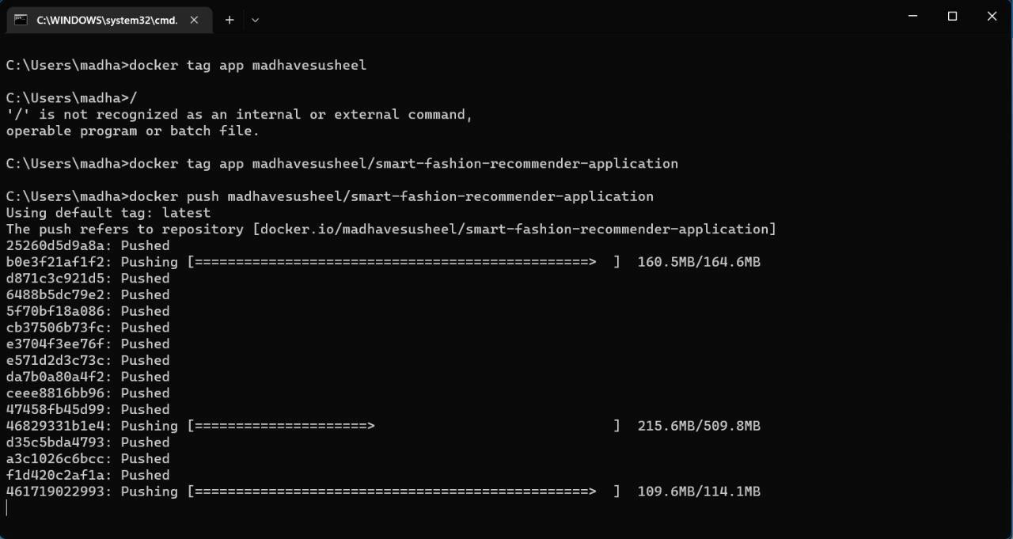

CONTAINERIZING THE APPLICATION:

